mohan raj: how to print ffractional part alone in number

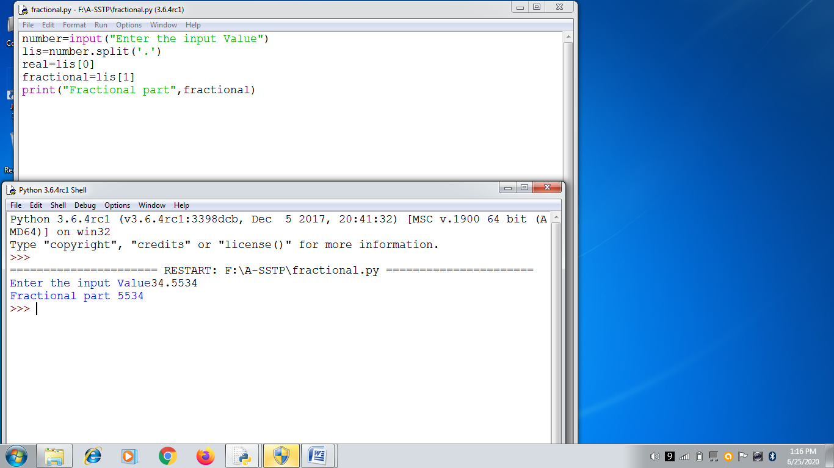

number=input("Enter the input Value")

lis=number.split('.')

real=lis[0]

fractional=lis[1]

print("Fractional part",fractional)